File Server

✅ What is a File Server?
# Source: AI Source: Provided by: [Data Path: Persons Table -> ID Column: 1, Name_En Column: Motasem Essam] -> From: [ChatGPT] on [1/16/2026]
A File Server is a computer or system on a network that stores and manages files so other devices (clients) can access, share, and manage them.
Think of it as a shared folder hub where users can upload, download, or edit documents, images, or software.

🧱 Purpose of a File Server:
# Source: AI Source: Provided by: [Data Path: Persons Table -> ID Column: 1, Name_En Column: Motasem Essam] -> From: [ChatGPT] on [1/16/2026]
Task | Description
📦 Centralized Storage | Stores files in one place instead of scattered devices
👥 Shared Access | Allows multiple users to access the same files
🔐 Permissions | Controls who can read/write/modify files
🕒 Backup & Recovery | Makes file backup and version control easier

📶 How It Works:
# Source: AI Source: Provided by: [Data Path: Persons Table -> ID Column: 1, Name_En Column: Motasem Essam] -> From: [ChatGPT] on [1/16/2026]
- Admin creates shared folders on the file server
- Users connect over the network (LAN or internet)
- Users access files via:
  - File Explorer (Windows)
  - Finder (macOS)
  - FTP/SFTP/SMB/NFS protocols
  - Web interface

🧑‍💻 Example Use Cases:
# Source: AI Source: Provided by: [Data Path: Persons Table -> ID Column: 1, Name_En Column: Motasem Essam] -> From: [ChatGPT] on [1/16/2026]
Scenario | File Server Role
Office sharing documents | Central place for Word, Excel, PDF files
Software deployment | Hosts installers for employees
School network | Stores assignments & teaching materials
Media team | Shares large videos or design assets

🛠 Common Protocols:
# Source: AI Source: Provided by: [Data Path: Persons Table -> ID Column: 1, Name_En Column: Motasem Essam] -> From: [ChatGPT] on [1/16/2026]
Protocol | Meaning | Used For
SMB | Server Message Block (Windows) | Windows file sharing
NFS | Network File System (Linux) | Unix/Linux file sharing
FTP/SFTP | File Transfer Protocol | Remote access over internet
HTTP | Web-based file browsing | Downloading/uploading via browser

🧭 Example:
# Source: AI Source: Provided by: [Data Path: Persons Table -> ID Column: 1, Name_En Column: Motasem Essam] -> From: [ChatGPT] on [1/16/2026]
- IP: 192.168.1.100
- Shared folder: \\192.168.1.100\SharedFiles
- User accesses it via File Explorer or mounts it as a drive

📊 File Server vs Database Server
# Source: AI Source: Provided by: [Data Path: Persons Table -> ID Column: 1, Name_En Column: Motasem Essam] -> From: [ChatGPT] on [1/16/2026]
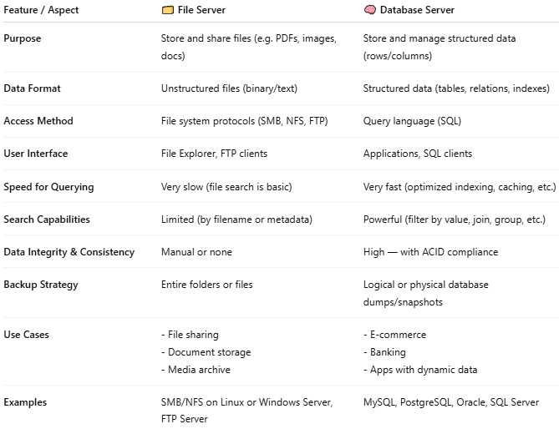

Feature / Aspect | 🗂️ File Server | 🧠 Database Server
Purpose | Store and share files (e.g. PDFs, images, docs) | Store and manage structured data (rows/columns)
Data Format | Unstructured files (binary/text) | Structured data (tables, relations, indexes)
Access Method | File system protocols (SMB, NFS, FTP) | Query language (SQL)
User Interface | File Explorer, FTP clients | Applications, SQL clients
Speed for Querying | Very slow (file search is basic) | Very fast (optimized indexing, caching, etc.)
Search Capabilities | Limited (by filename or metadata) | Powerful (filter by value, join, group, etc.)
Data Integrity & Consistency | Manual or none | High — with ACID compliance
Backup Strategy | Entire folders or files | Logical or physical database dumps/snapshots
Use Cases | - File sharing- Document storage- Media archive | - E-commerce- Banking- Apps with dynamic data
Examples | SMB/NFS on Linux or Windows Server, FTP Server | MySQL, PostgreSQL, Oracle, SQL Server

✅ Summary
# Source: AI Source: Provided by: [Data Path: Persons Table -> ID Column: 1, Name_En Column: Motasem Essam] -> From: [ChatGPT] on [1/16/2026]
Feature | Description
Centralized files | Shared access for many users/devices
Permission control | Decide who can read, write, or delete
Backup-ready | Easy to back up from one location

